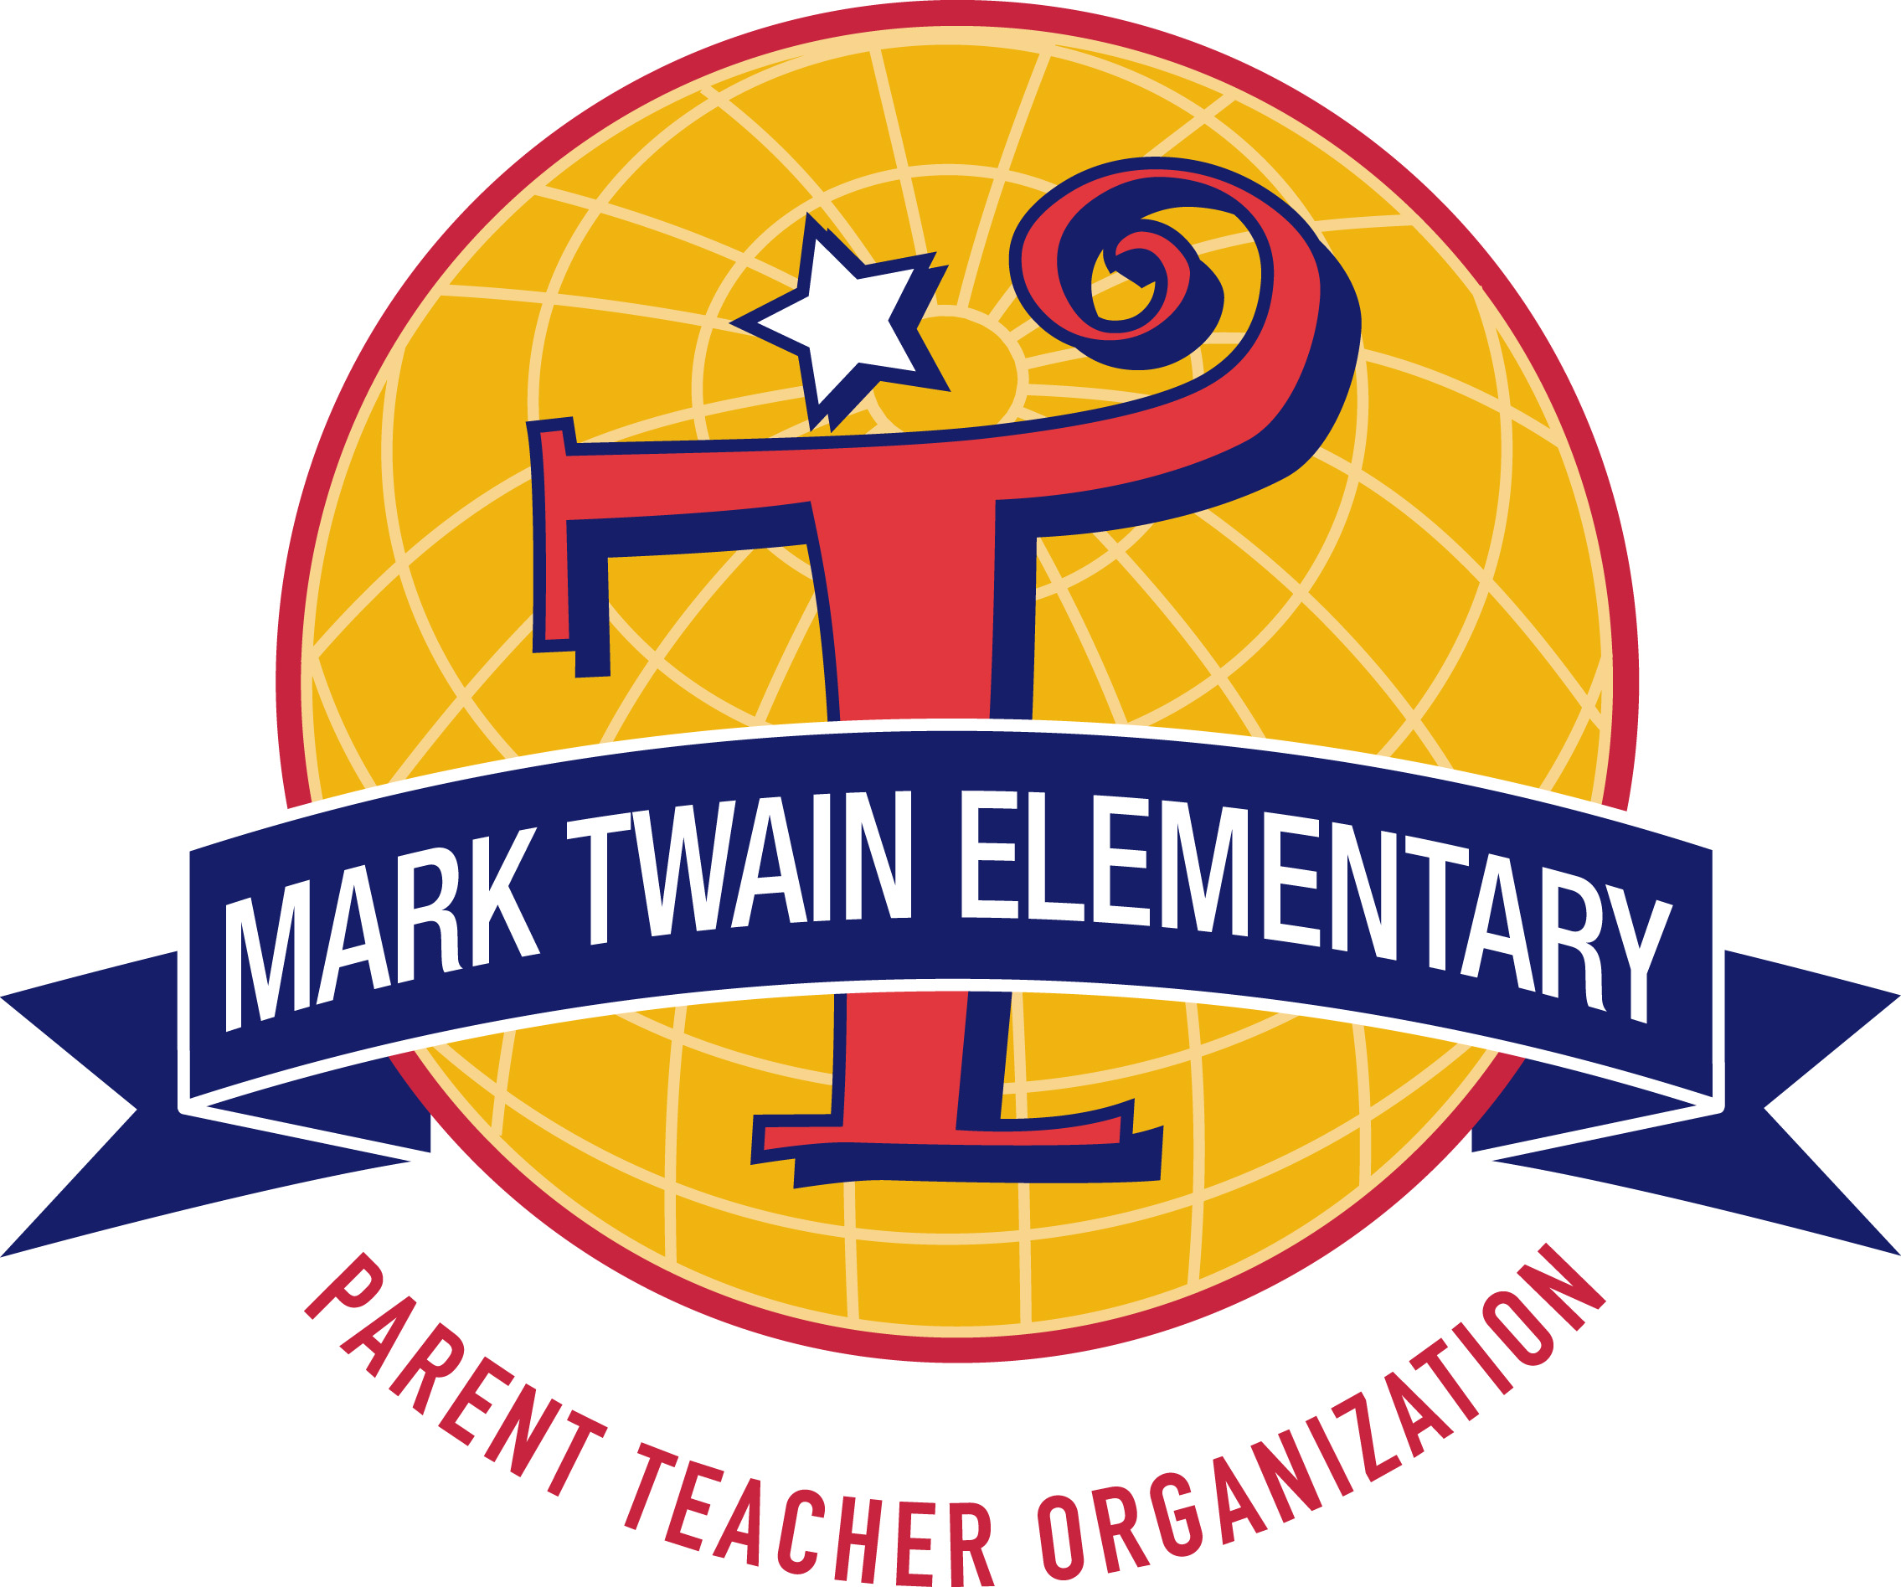
Teacher: ___________________
Class Volunteer List
2022-2023

There are many wonderful opportunities for you to volunteer in your child’s class this year!

Please sign up, including your name and email address.

Room Parent(s)
Name | Email

Class Directory Make and distribute a class directory that includes phone numbers and e-mail addresses so that you and other parents can easily contact each other.

Class Directory
Name | Email

Weekly Classroom Communications Folder Coordinator *TBD – How this will be done this year. Get class basket with folders from classroom at drop off and check in with Tuesday Folder Rep in cafeteria to receive paperwork to put in folders and return basket to classroom.

Communication Folders
Name | Email

Class T-Shirts Create a design using the class nickname (given to you by the teacher) and order shirts class T-shirts.

Class Shirt
Name | Email

Class Photographer/Yearbook Take photos of special events, help yearbook staff with the class page.

Class Photographer
Name | Email

Class Party There are typically 2 per year. Consult with the classroom teacher before scheduling and then send out email requests to parents if needed.

Class Party
Name | Email

Field Day Create a design using the class nickname (given to you by the teacher) and bring refreshments for the class on the day of Field Day.

Field Day
Name | Email

Spooky Spectacular Create a Signup Genius for the class to provide volunteers for Spooky Spectacular. Coordinator class volunteers for Spooky Spectacular.

Spooky Spectacular
Name | Email

Huckleberry Bash Donation Coordinator is responsible for securing ONE donation on behalf of their classroom. Details and guidance will be provided by the Bash committee for the role.

Huckleberry Bash Class Coordinator
Name | Email

